Going Into a Museum

Soon, I will go to a museum. This Story is about how to go into a museum.

Many people go to museums. There may be a line of people waiting to go inside.

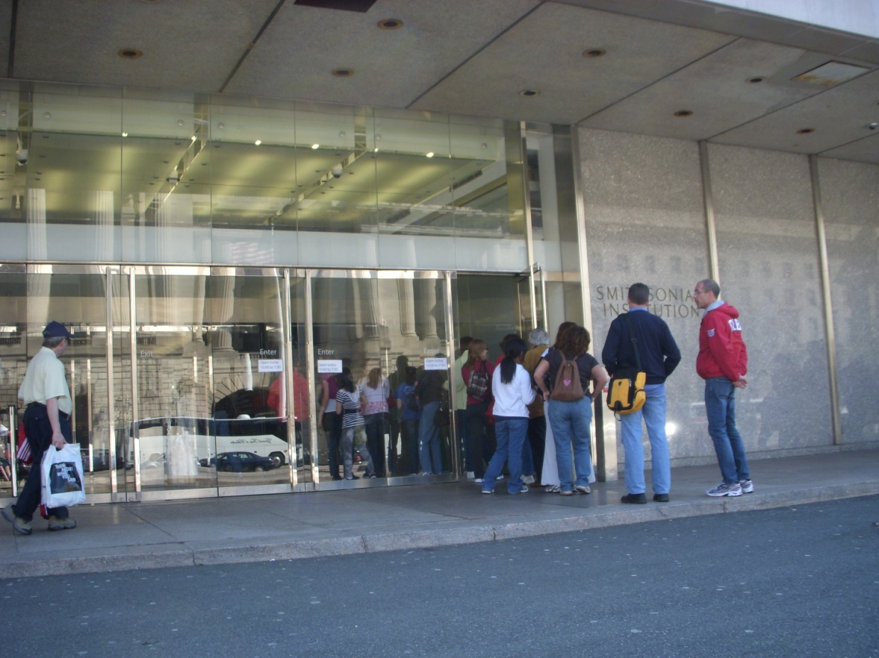
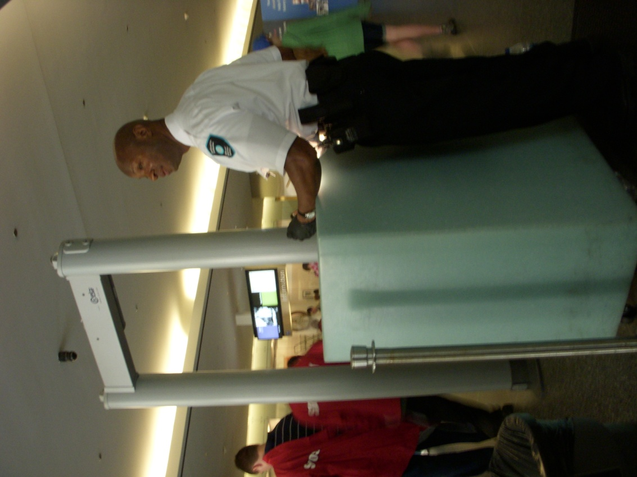

There is a security officer at each museum door. Security officers check all bags, handbags, and backpacks. This helps to keep everyone safe.
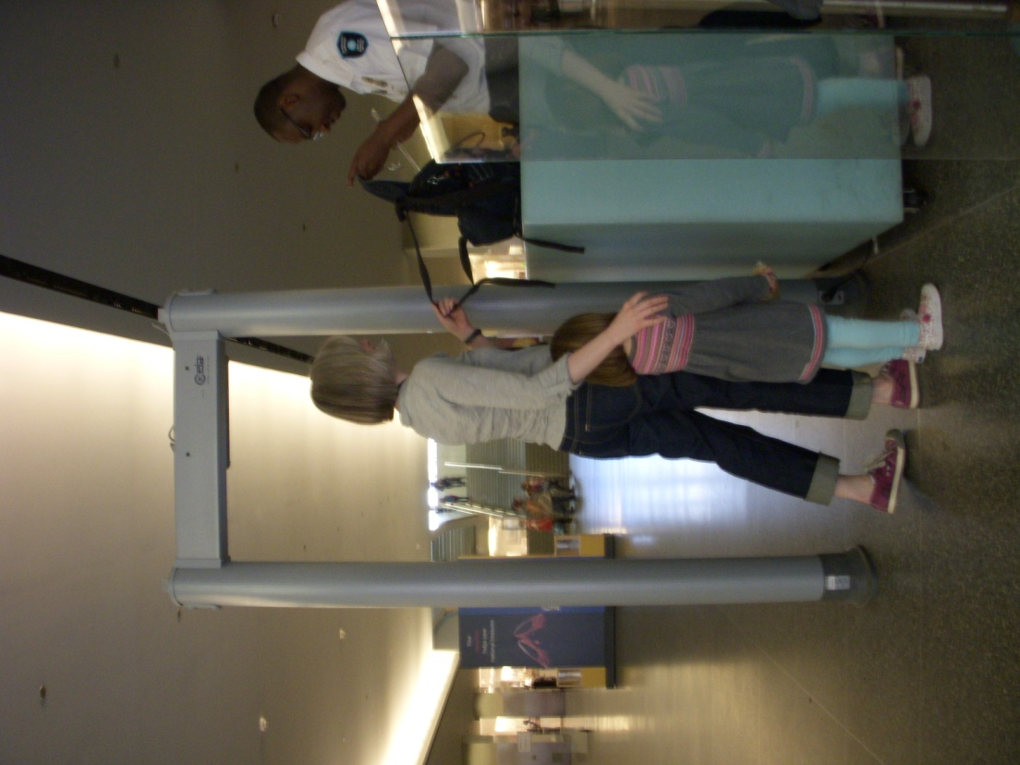
If I have a backpack or a bag, It is important to:
- Open my bag or backpack.
- Give it to the security officer.
- Walk through the scanner.
- Wait to get it back.

The security officer will tell me when I may go into the museum. I will go in with my adult.
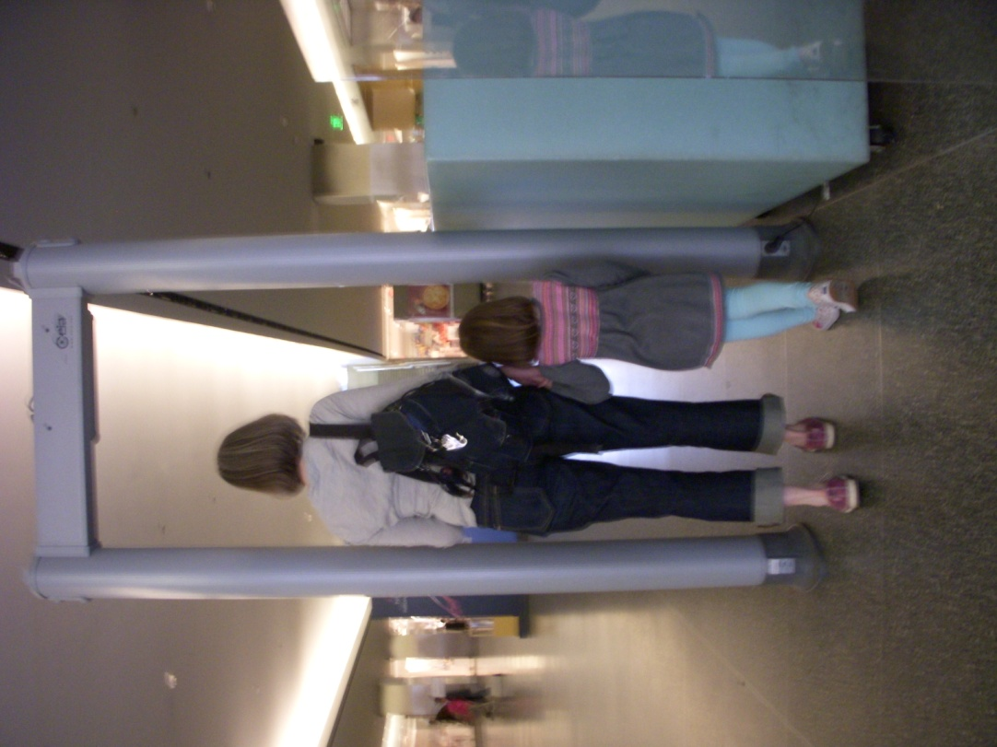

I will go to a museum soon. There may be a line of people. A security officer will check each bag. I will try to think about this Story. That way, I may know what to do.

